- Regression, part b
2.1) Two level cross validation is implemented using Algorithm 6. and baseline model with no feature values are implemented in Two level cross validation and predicted Y on the test data. ANN model is also implemented in using two level cross validation.

For Baseline model, linear regression model with no features is implemented. This computes the mean square error on the train data and test data. The interpreted values are as follows

Linear regression without feature selection:
- Training error: 0.7812252532076115
- Test error: 0.8548330798642233
- R^2 train: 0.4184089511032533
- R^2 test: 0.3484378681795293

The training error and the test error is computed with the following formula:

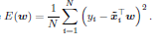
On analysing the results the test error is slightly higher than the training error in the baseline model.

For Regularized Linear Regression we computed 2 level cross validation and the generalization error we got is shown in the figure below.

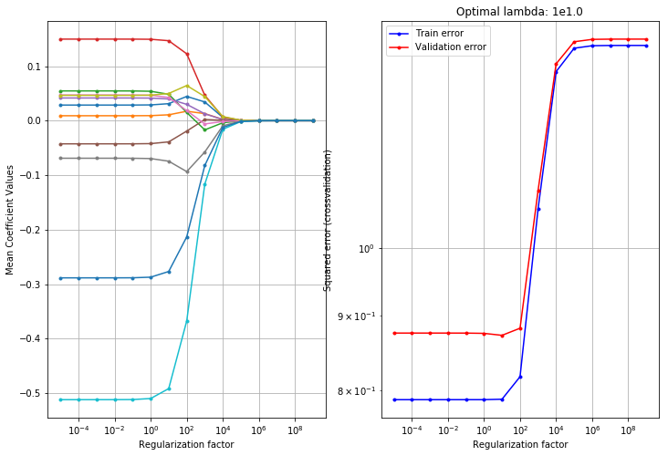

Figure 2.2a Figure 2.2b
For the Regularized linear regression model the Λ values are chosen between to . One can observe that, as Λ increases the mean coefficient values decreases. When the there is less Λ the model is having high variance and low bias. When there is more Λ the model is having low variance and high bias. It can be observed from the above Figure 2.2b that the minimum test error can be found around Λ = . After the Λ= the error starts increasing.

Regularized linear regression:
- Training error: 2.424352245067184
- Test error: 2.418912805464008
- R^2 train: -0.8052231108473349
- R^2 test: -0.8781909105713602

The training error and the test error doesn’t have much difference.

For ANN we computed 2 level cross validation. The below figure shows how the input data is predicted based on the Neural Networks. The neural network consists of 3 units. Input unit, output unit and the hidden unit. The red and green lines in the below figure are the weighted connections. Here to save the time we reduced the number of iterations to 100. The Average error for the ANN model is 0.861.

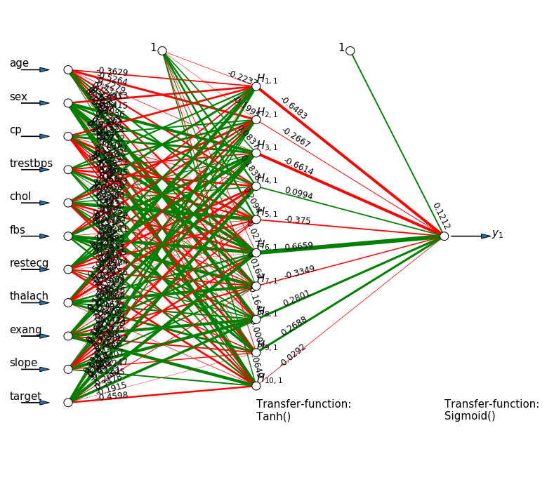
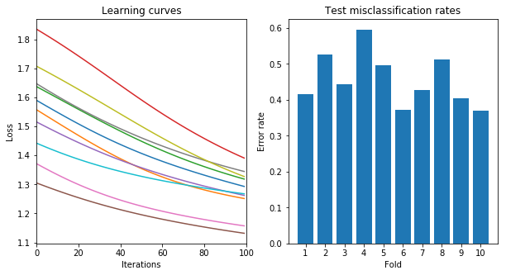
From the above figure we can clearly see that this model needs some more iterations to check the learning curves. But we can see that as the more the iterations the lesser the losses. We can clearly interpret that 6th Fold has low error rate compared to the all folds.
2.2)

K1- Outer fold | ANN |  | Linear Regression |  | Baseline
1 | 4 | 0.99 | 9.5e-02 | 5.789 | 0.765
2 | 3 | 1.81 | 2.6e+01 | 9.347 | 0.800
3 | 7 | 0.66 | 1e+02 | 8.53 | 0.795
4 | 9 | 0.79 | 1e-05 | 9.65 | 0.804
5 | 8 | 0.66 | 1e-05 | 5.66 | 0.811
6 | 4 | 0.99 | 5e+01 | 11.38 | 0.832
7 | 3 | 1.81 | 1.3e+01 | 4.27 | 0.826
8 | 7 | 0.69 | 2.2e+02 | 8.54 | 0.847
9 | 7 | 0.58 | 1e-05 | 10.8 | 0.869
10 | 8 | 0.22 | 2.68e+01 | 5.55 | 0.857

If we compare the linear regression and the Baseline model, it can be concluded that the Base line model without any features is the best model. It has low errors. This is because our observations are very low and this data is classification based. When comparing our data with ANN model, we can observe that the average of test errors is 1.065. where as for baseline the average is 0.08206. So on comparing the ANN is better than the Linear Regression. But on comparing with the Baseline ANN is having large error. The number of iterations used here are 1000, if we increase our iterations the model will give better results than the Baseline Model.

2.3)
In this part we need to compare three models with each other, for that we use credibility interval method . we can use this interval to determine whether one model is better that the other. We can calculate the difference and generate a 95% credibility interval based on this difference.
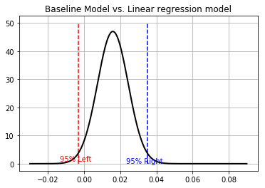
The above figure is the comparison between Baseline Model and Linear regression Model. Hear we can observe that the two models is in between -0.3 and 0.03. where this has negative lower bound and positive higher bound which tells that there is no big difference between the two models. We can also interpret that by looking at the mean value. We can see that the mean value is almost ‘0’, representing not much difference between two models.

Model | K | V | Mean | Sigma
Baseline vs Linear Regression | 10 | 9 | 0.0158 | 0.008 | -0.0033 | 0.035
Baseline vs ANN | 10 | 9 | -0.0008 | 0.1858 | -0.421 | 0.492
ANN vs Linear Regression | 10 | 9 | -1.4688 | 0.2367 | -2.004 | -0.933

The above figure is the comparison between ANN vs Basline. Hear we can observe that the two models is in between -0.4 and 0.4. where this has negative lower bound and positive higher bound which tells that that there is no big difference between the two models. We can also interpret that by looking at the mean value. We can see that the mean value is ‘0’, representing not much difference between two models.

The above figure is the comparison between ANN vs Linear Regression. Hear we can observe that the two models is in between -2.0 and -0.9. where this has negative lower bound and negative higher bound which tells that that there is significantly big difference between the two models. We can also interpret that by looking at the mean value. We can see that the mean value not close to ‘0’, representing the difference between two models.

